# Hands-on Assessment (Power BI)

## Eeshita Deepta, 654982

DATA LOADING

Creating tables in SQL Server

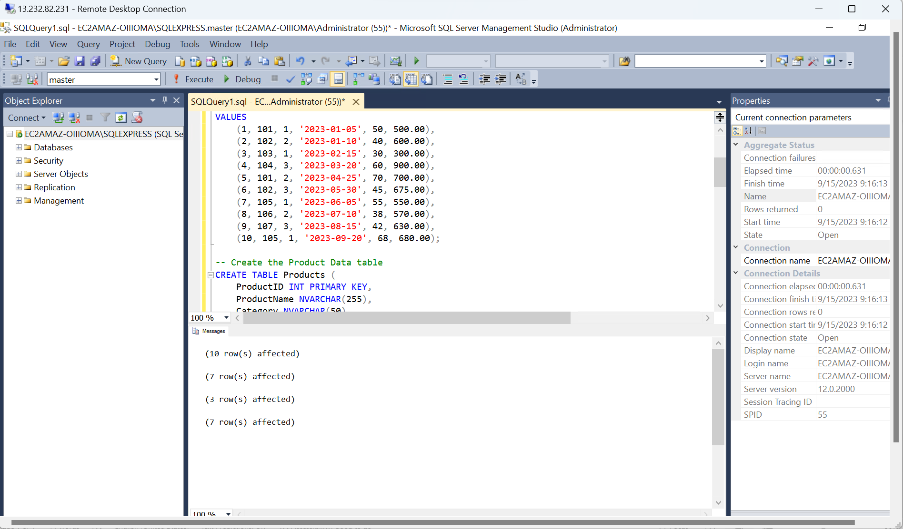

Connecting SQL Server to Power BI

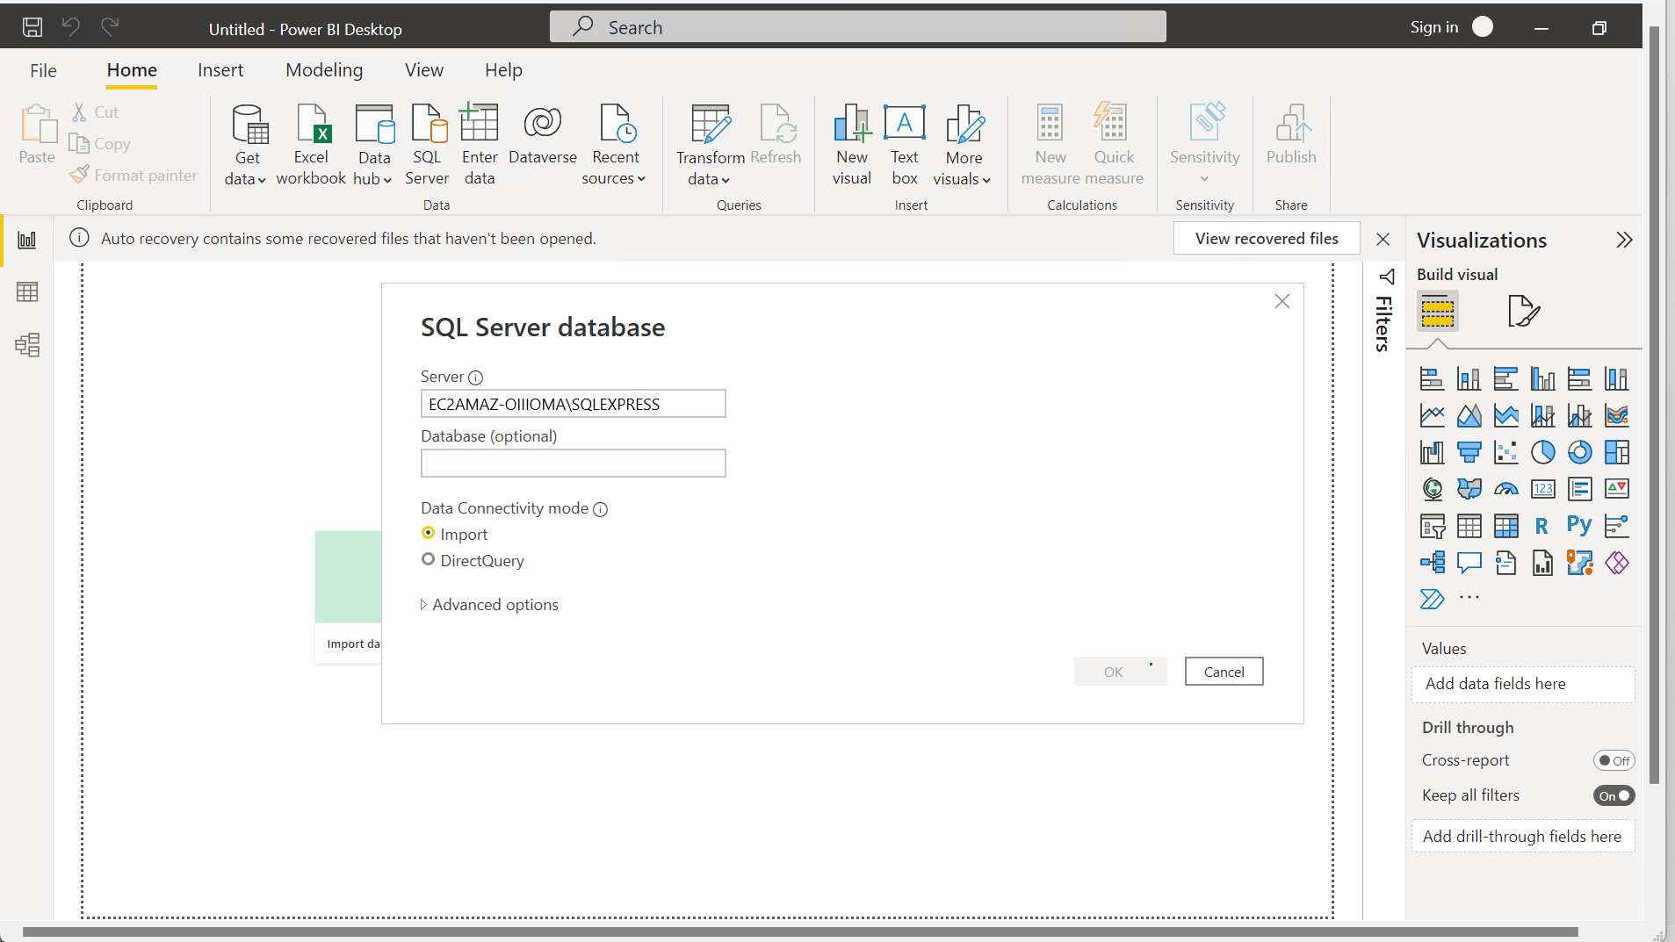

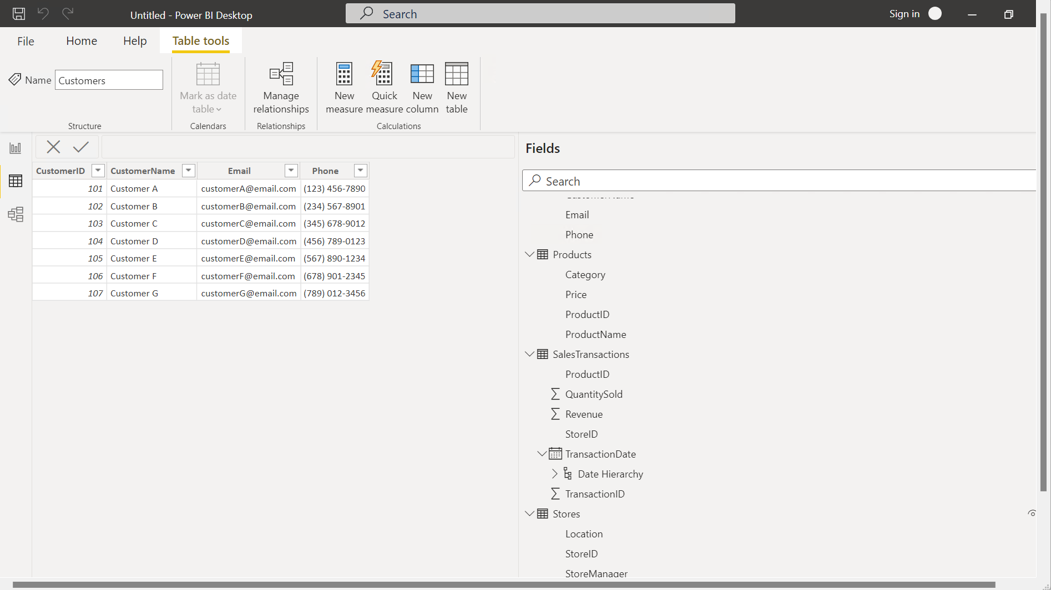

DATA TRANSFORMATION

Using Power Query Editor

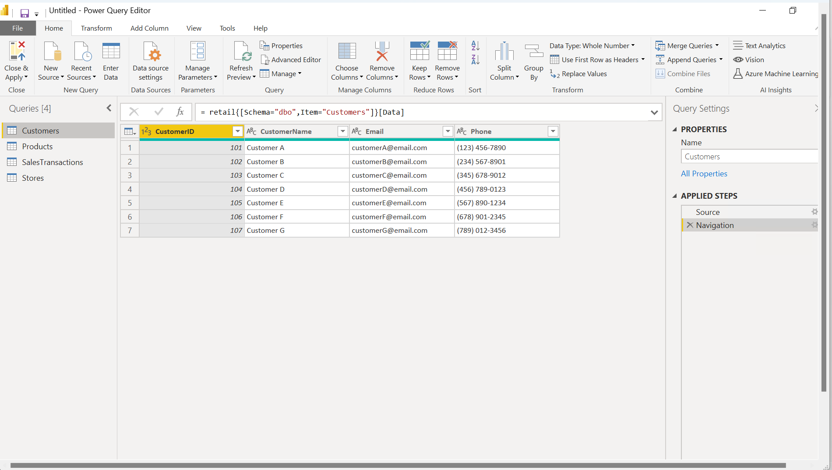

Merging Tables

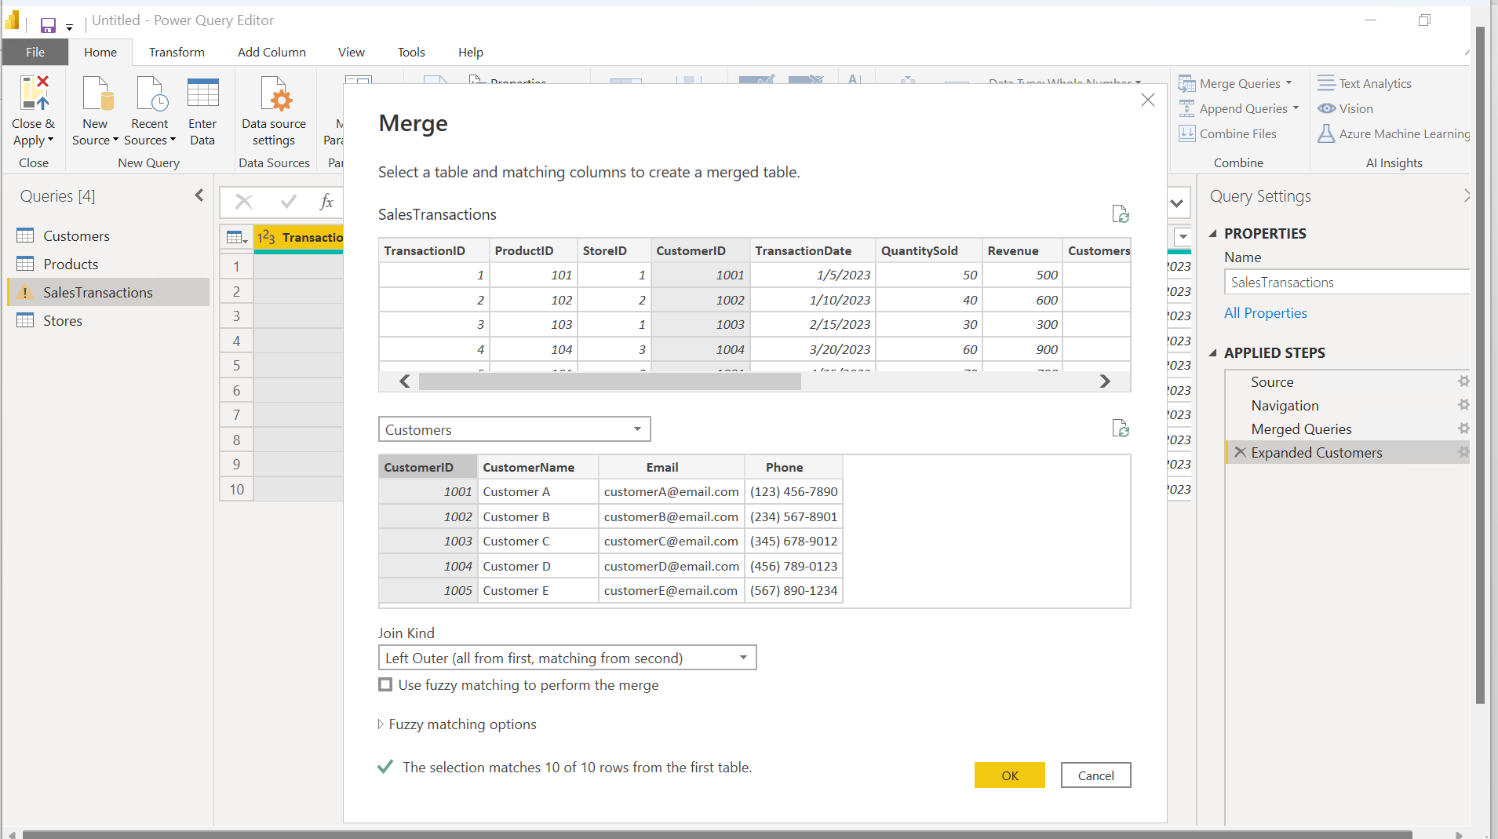

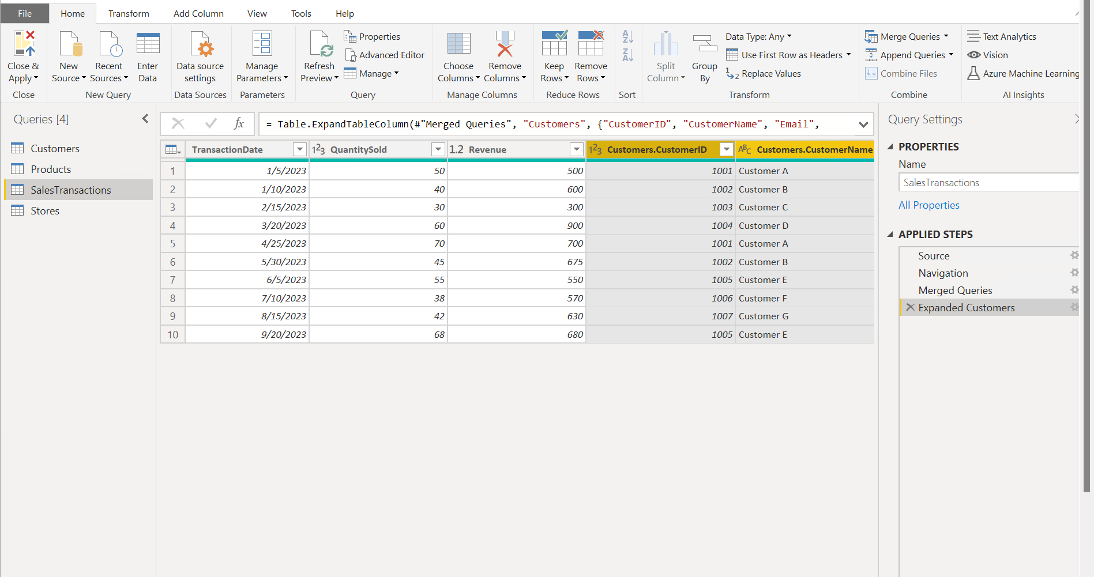

Clean Data

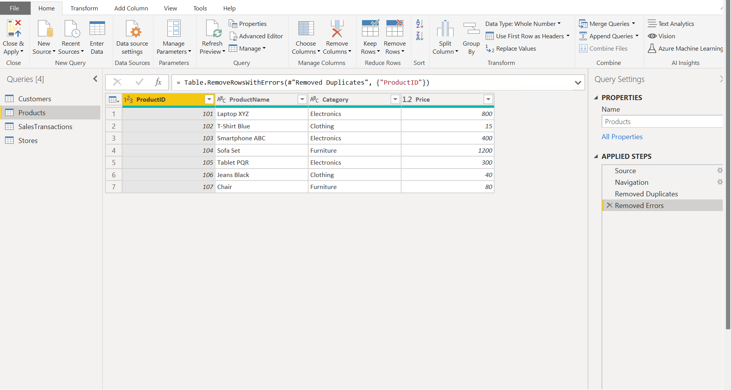

Creating Calculated Column

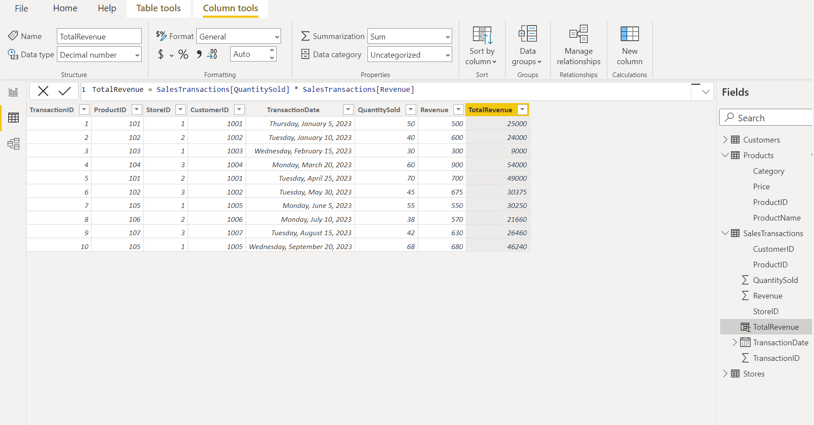

Filter Data

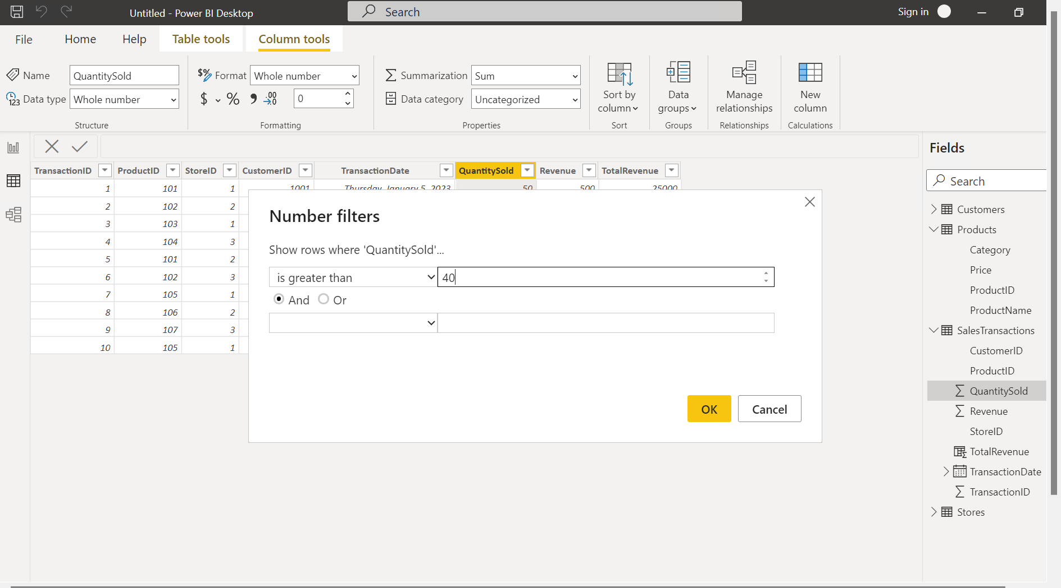

DATA MODELLING

Create relationships

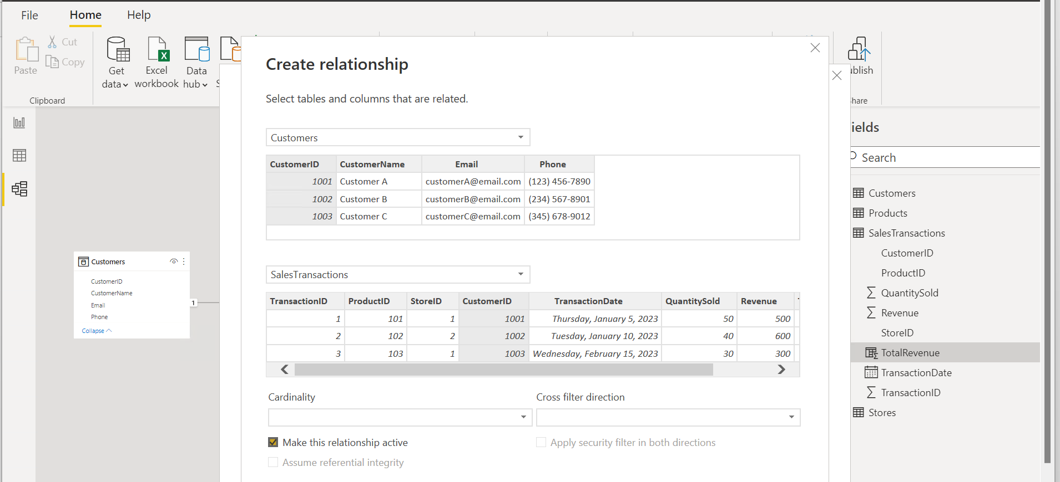

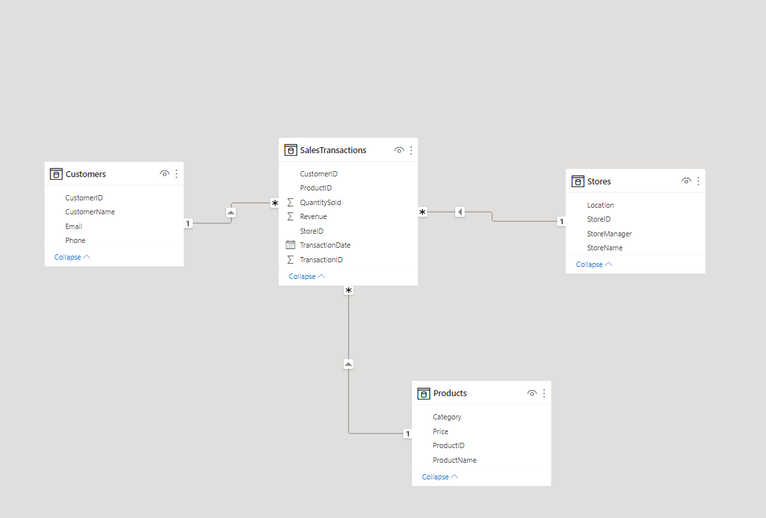

Creating Hierarchy

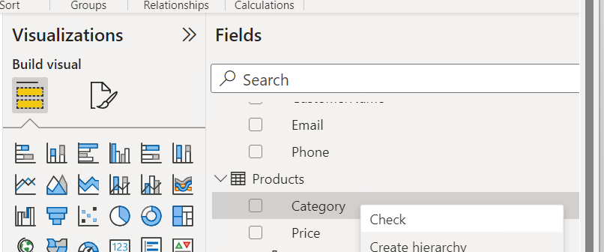

BUSINESS QUERIES AND ANALYSIS

1. Who are the top-spending customers based on their total purchase amount?

1. How is sales revenue distributed among different store managers?

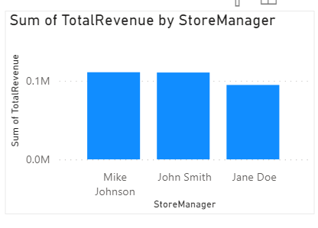

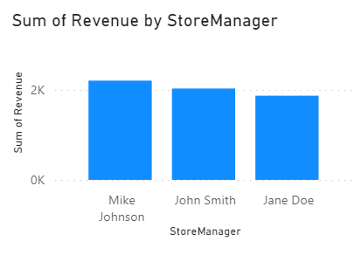

1. What is the average price of products in each category?

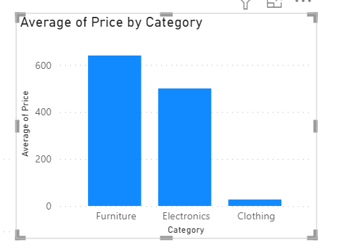

1. Are there specific days of the week when sales are higher?

1. How do sales trends vary by product category on a monthly basis?

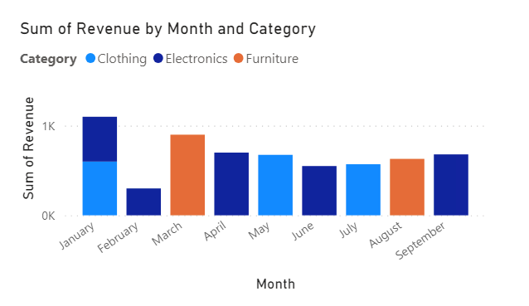

1. What percentage of products account for 80% of total sales revenue?

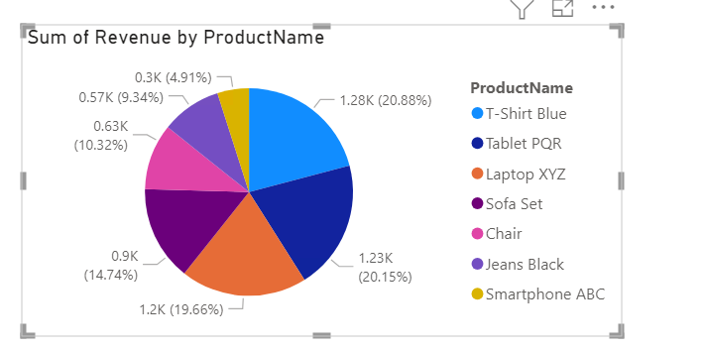

T-Shirt Blue, Tablet PQR, Laptop XYZ, Sofa Set, Chair

1. Are there any trends in repeat customer purchases?

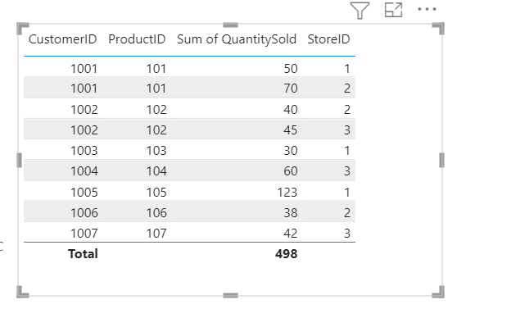

Customers tend to purchase the same products again even if at a different store

1. Which product categories perform best at each store loca;on?

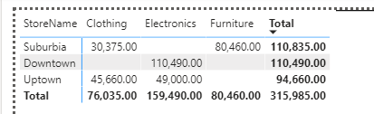

At Suburbia, Furniture performs best. Electronics at Downtown and Uptown.

1. Are there any seasonal paSerns or trends in sales for specific products or categories?

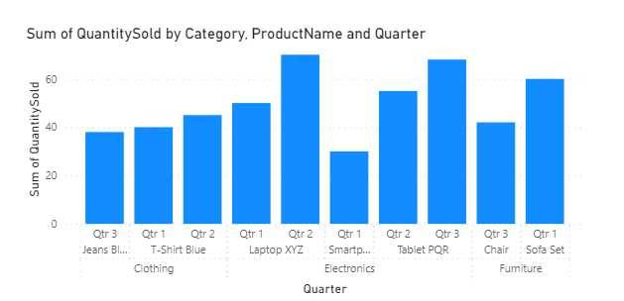

1. Can customers be segmented into high, medium, and low-value segments based on their purchase history.

DATA INSIGHTS AND RECOMMENDATIONS

* Customers tend to buy the same products again, even if at different stores.
* Some stores are much better at selling one category than other.
* Although most customers generate high revenue, most don’t.
* There are seasonal variations present when it comes to sale of different categories.



